
Teton County WY Household Preparedness Plan
This template is provided by Teton County WY Emergency Management specifically for individuals, households, and families living in Teton County, WY. This template aligns with the Teton County/Jackson Emergency Operations Plan (EOP) and the Wyoming Region 8 Hazard Mitigation Plan.
Teton County’s government-level emergency plans can be found at https://www.tetoncountywy.gov/326/Emergency-Plans
Work together as a household on this template to get everyone’s feedback. Knowledge is power during a disaster, and this plan is your household’s first step towards getting ready!

Prepared for: _____________________________________________________________

Date: _______________________________________________________________________

Next Review Date: _______________________________________________________

Template version 1.1

Template date 01/21/2026

This template was created with AI assistance (ChatGPT 4.o, July 2025) with final editing and review by Teton County Emergency Management staff.

🌪️ 1. Hazards We're Preparing For
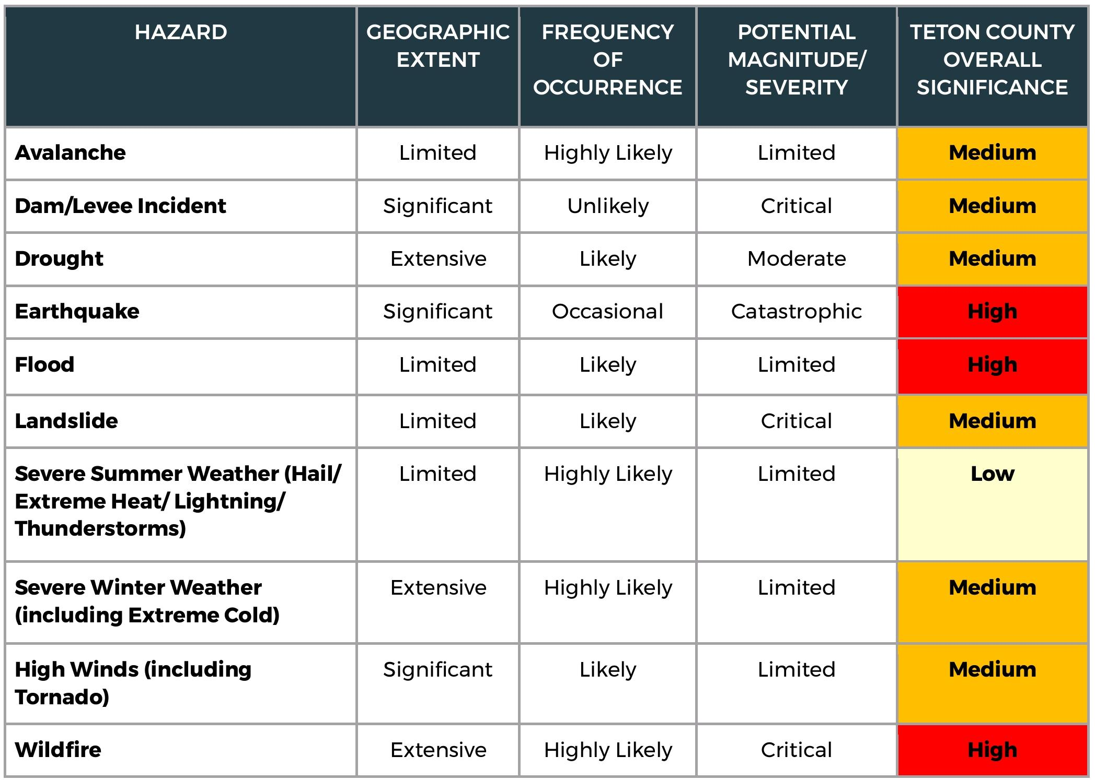
Teton County covers a wide range of terrain and environments, which means hazard risks vary depending on where your home is located. Use the list below as a guide based on the Region 8 (Teton County) Hazard Mitigation Plan, but personalize it to your specific area and concerns. Below is a table from the 2025-2030 Hazard Mitigation Plan evaluating natural (not human caused or terrorist) hazards:

Understanding Disaster Types
Disasters are commonly grouped into three categories:
- Natural disasters are caused by natural processes such as weather or geology. These include events like a severe winter storm or earthquake.
- Technological disasters result from failures in systems or infrastructure, such as a widespread power outage or a dam failure.
- Human-caused disasters are intentional acts that cause harm, such as terrorism or cyber-attacks.
Knowing the types of disasters helps you think through the full range of risks your household may face.

Now, considering natural, technological, and human-caused hazards, check the hazards that concern your household and click the links to learn more about each:
- Attacks or Explosions in public places
- Avalanche
- Dam Failure
- Drought
- Earthquake
- Flooding
- Chemical Emergency (Household)
- Chemical and Hazardous Materials Incidents (Industrial)
- House Fire
- Landslide
  - Visit the Wyoming State Geological Survey’s Landslide Susceptibility Map for Teton County
- Pandemic or Health Emergency
- Severe Summer Weather (thunderstorms, high winds, hail, extreme heat)
- Severe Winter Weather (snow, blizzard, extreme cold)
- Space Weather
- Utility Outage (electricity, water, sewer, propane, natural gas, phone, internet, etc.)
- Volcanoes
- Wildfire
- Other:

Take a moment to review details about all your hazards of concern by visiting www.ready.gov for hazard-specific tips and other preparedness resources.

👨‍👩‍👧‍👦 2. Household Members’ Contact Information
Now we’ll create a contact list of everyone in the household. Keep a copy of this page in your backpack, purse, car, or briefcase so you always have it with you. It’s also a good idea to back up your cell phone contacts to the cloud and know how to access them from someone else’s device in case you lose your phone in a disaster.
Name | Mobile Phone | Email | Role

💊 3. Medications and Prescriptions
Maintain a list of all essential medications for household members and pets. Ensure you have at least a 2-week supply, spare prescription/reading glasses, and store copies of prescriptions in secure cloud storage. If you are in an emergency shelter and don’t have your medications, you can use this list with client case workers to help get your important medications.
Medication for: | Medication | Dosage | Notes
Use additional pages if necessary

📇 4. Important Numbers and Contacts
Your local emergency contact is a trusted friend or neighbor that can lend a hand during a crisis. Your out-of-town emergency contact is someone outside of the region that everyone in your family can contact to check in with if local communications are down after a disaster.

Local Emergency Contact:
Name | Address | Phone | Email

Out-of-Town Emergency Contact:
Name | Address | Phone | Email

Schools:
Name | Address | Phone

Workplaces:
Name | Address | Phone

Other Contacts:
Name | Address | Phone

Other Important Contacts:
Name | Address | Phone
ALL EMERGENCIES | Teton County WY Sheriff’s Office Dispatch | 9-1-1
Non-emergency | Teton County WY Sheriff’s Office Dispatch | (307) 733-2331
Family Doctor
Veterinarian
Electric Utility
Gas Utility
Phone Utility
Internet Utility
Water Utility
Insurance Agent

📦 5. 2 Weeks Ready Kit Checklist
Wyoming is a remote place. Prepare for at least two weeks of self-sufficiency. Build your kit over time, use items you may already have in your camping gear, and check your kit annually when you update your plan.
- Water: 1 gallon per person/pet per day for 14 days (less water if you have purification)
- Water purification (filter, tablets, boiling method)
- Non-perishable food for 14 days (e.g., fruit/tuna in water, peanut butter, crackers, high-protein bars, canned beans, dehydrated meals, meals ready to eat [MREs])
- Copy of this emergency plan
- 2 weeks of medications
- Spare prescription and reading glasses
- NOAA Weather Radio and AM/FM radio (battery-powered)
- Cell phone with backup battery/charger
- Flashlight and extra batteries
- First aid kit
- Cash in small denominations
- Hygiene items (toilet paper, sanitizer, moist towelettes, tissues, plastic trash bags)
- N95 masks
- Warm clothing, extra socks, sturdy shoes, blankets
- Multi-tool or pocketknife
- Work gloves
- Whistle
- Parachute cord or rope
- Pencil and paper
- Books/games for comfort
- Pet/livestock supplies
- Emergency documents stored securely either in the cloud, on a secure USB flash drive, and/or in your kit in a waterproof bag such as:
  - Birth certificates
  - Social security cards
  - Passports or green cards
  - Driver’s licenses
  - Marriage/divorce/adoption/custody records
  - Military or tribal ID
  - Pet ownership documents/microchip records
  - Health/dental insurance cards
  - Living will and medical power of attorney
  - Deed and property titles
  - Insurance policies
  - Photos/appraisals of valuables for insurance claims
2 Weeks Ready Kit Location: ____________________________________________________________________

💰 6. Emergency Financial Planning

Insurance Policies:
Policy Type | Insurer | Policy #
Home/Renters
Auto
Health
Life

Bank Accounts (store complete information securely online):
Bank | Type | Last 4 Digits

📢 7. Public Alerts and Warnings
You can’t take action to protect yourself and your family if you don’t have official and accurate information. Knowing how to receive alerts and warnings in Teton County is a key part of your preparedness plan.

Teton County Mass Notification System
Managed by Teton County Emergency Management, Teton_WY Alerts powered by Everbridge is Teton County’s emergency mass notification system. Make sure everyone in your household is registered for Teton_WY Alerts at https://tcincident.org and click “Sign Up”. Be sure to log into your Teton_WY Alerts account annually to update your information
- All adults in household are registered for Teton_WY Alerts

Wireless Emergency Alerts (WEA)
Enabled on most modern cell phones unless disabled by the user, WEAs are another way that Teton County Emergency Management can reach you with emergency information. Similar to a text message, but with a different alert tone. Be sure that you have WEAs enabled on your phone.
- Everyone with a cell phone has checked settings to make sure that WEA is enabled for Extreme and Severe threats (search “Emergency Alerts” in phone settings)

NOAA All-Hazards Weather Radio
NOAA Weather Radio broadcasts weather information from the National Weather Service office in Riverton, WY 24 hours a day, 7 days a week. During emergencies, the radio can be activated with an alert tone to broadcast important emergency information. These inexpensive radios can be purchased from major online retailers and come in portable battery powered versions for your 2 Weeks Ready kit or home versions that can be kept in your bedroom. These are the transmitters for Teton County, WY:
• KWN39 – 162.525 MHz (Snow King Mtn)
• WNG686 – 162.500 MHz (Elk Plaza)
• WNG667 – 162.550 MHz (Grant Village)
• KJY57 – 162.450 MHz (Relay Ridge, Alta WY)
- NOAA Weather Radio in home, on and ready to receive alerts
- NOAA Weather Radio in 2 Weeks Ready kit
- Check for good reception of NOAA radios at least monthly

Emergency Alert System (EAS)
The EAS will broadcast important emergency information during significant disasters. You can get EAS messages from these local radio and television broadcasters in Teton County, WY:
• KJAX 93.5 FM
• KZJH 95.3 FM
• KMTN 96.9 FM
• KSGT 1340 AM / 96.3 FM
• KHOL 89.1 FM
• KMLT 88.3 FM
Television: Spectrum Cable
Note that satellite radio and television broadcasters only relay national level EAS messages. You will not receive local EAS messages from satellite providers. Also, although Wyoming Public Radio 90.3 FM is a local channel, currently they only broadcast EAS messages for statewide emergencies.
- AM/FM radio has at least one of the stations above programmed into presets

Outdoor Warning Sirens
Sirens are designed to warn people who are outdoors that something is wrong. They are used for various types of incidents, so if you hear a 3 minute long wail or longer, check Teton_WY Alerts, radio, television, www.tcincident.org, or NOAA Weather Radio for more information.
• Locations: Teton Village, Teton Pines, Wilson, downtown Jackson, Gregory Lane, Adams Canyon, Hoback Junction
• Depending on weather, air density, humidity, etc., each siren has an outdoor audible range of 0.5 to 1 mile from the siren.
• 1-minute wail = test | 3-minute wail = real emergency
• Map: https://www.tetoncountywy.gov/498/Outdoor-Warning-Sirens
- Checked outdoor warning siren map to see if home, work, and school locations are within audible range of a siren.

TCincident.org
This is Teton County Emergency Management’s emergency information landing page. Visit www.tcincident.org for current local incident information and to sign up for Teton_WY Alerts.
- Bookmarked www.tcincident.org on web browsers and mobile devices.

Social Media
Teton County Emergency Management maintains social media pages on Facebook and X (Twitter). These can be used for relaying emergency info, especially if other systems fail.
- Followed @teton.wy.ema on Facebook https://www.facebook.com/teton.wy.ema
- Followed tetonwyo_em on X (Twitter) https://x.com/tetonwyo_em

State Highway Alerts
Most major roads in Teton County are Wyoming State highways. This includes Snake River Canyon, Hoback Canyon, Teton Pass, Togwotee Pass, Highway 390, and more. Wyoming 511 is the system that can inform you of State highway issues and closures.
- Bookmarked www.wyoroad.info in web browser
- Signed up for 511 Notify text/email alerts for the State highways that are important to you at https://wyoroad.info/511/511NotifyAnnouncement.html

🚦 8. Teton County Protective Action Protocol
Protective Actions are things that public safety officials may ask you to do during an emergency to keep yourself and your household safe. Time is of the essence in an emergency, so simple language and instructions are important. That is why Teton County uses the READY, SET, GO!/STAY!/AVOID! model. This language will be used in alerts and warnings from Teton_WY Alerts, EAS, WEA, www.tcincident.org, and NOAA Weather Radio.
• READY: Develop a plan, assemble a kit, register for alerting systems, and test your plan. Teton County expects residents to be Ready all year round and will not put an area into a Ready stage. The steps you are taking by completing this plan are an example of a Ready action.
• SET: Conditions changing—review this plan with your household and stay tuned to official sources for further info.
• GO!: Immediate danger—leave now.
• STAY!: Shelter-in-place—safest to remain indoors.
• AVOID!: Keep away from emergency zones.
• RETURN: Follow official guidance to return home.
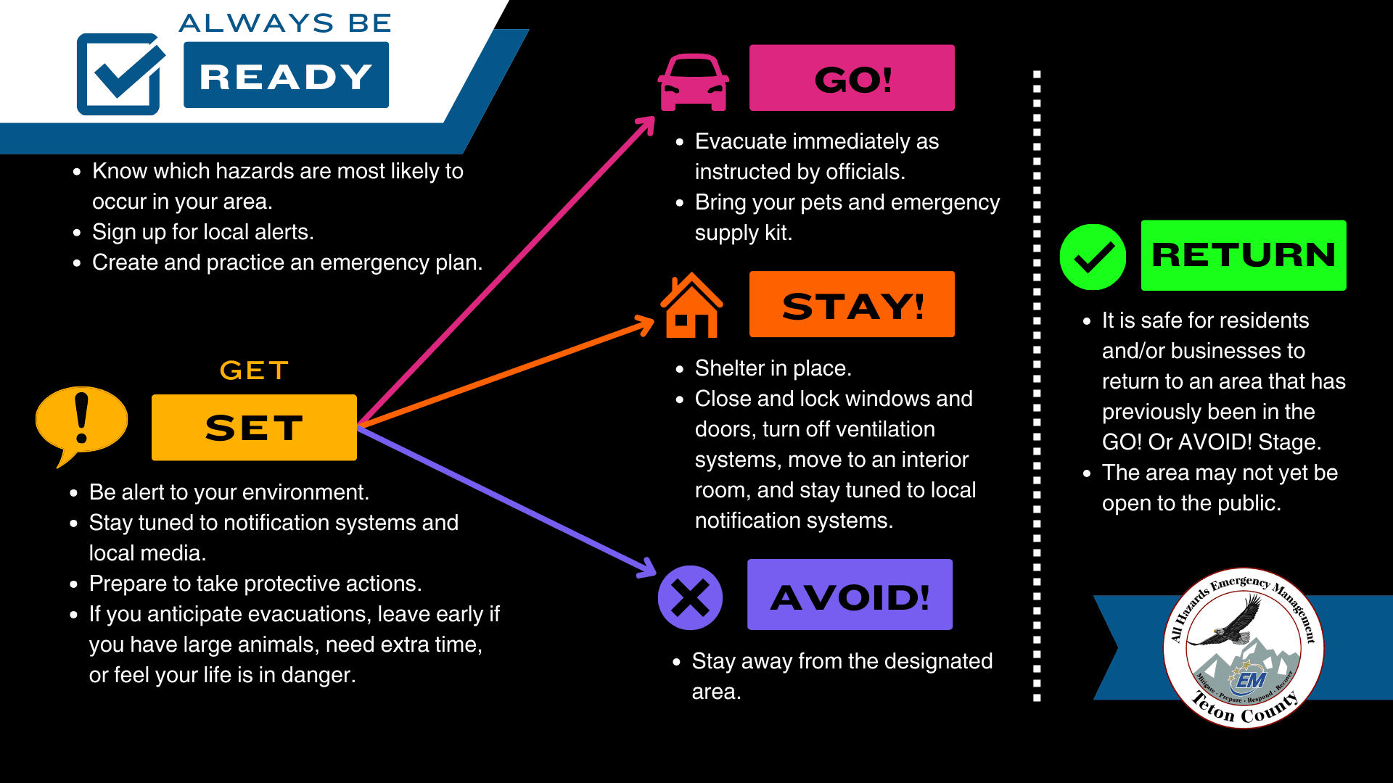

🐾 9. Pets and Livestock
Name | Type | License # | Microchipped? | Special Needs

Pre-identified Pet Friendly Hotels
Hotel Name | Phone | City

🚗 10. Evacuation Plan
If put into the GO! Stage, plan on how you and your family will evacuate.

Home Escape Routes (How you will get out of your home, like during a fire)
Escape Route Name | Description

Neighborhood Evacuation Routes (How you will get out of your neighborhood)
Evacuation Route Name | Description

Household Meeting Places
This is how you will reunite with your household if you must evacuate. If your neighborhood meeting place is inaccessible, go to your out-of-neighborhood meeting place. If that is inaccessible, go to your out-of-town meeting place. Be sure to wait for the pre-designated amount of time for other household members to show up. While you are waiting, call or text your Local and Out-of-Town Emergency Contacts from Section 4 of this plan to check in and see if your other household members may have done the same.
Meeting Place Name | Location | Wait here for at least:
Neighborhood Meeting Place
Out-of-Neighborhood Meeting Place
Out-of-Town Meeting Place

🏠 11. Shelter-in-Place Plan
Local officials may ask you to STAY! as a protective action. This means that staying put and sheltering in place is the safest action you can take. Prepare to shelter safely in emergencies like hazardous materials spills, storms, or violent threats. Ideally, your shelter room should be an interior room with as few windows, vents, or access to the outside as possible. Sheltering in place may be required for hours, or even days.
- Shut off HVAC, seal windows/doors during toxic releases.
- Stay away from windows during violent threats.

Designated shelter room: __________________________________________________________________________

Checklist for Shelter Room
- Cell phone and charger
- Backup battery power
- NOAA Weather Radio and AM/FM radio
- Medications & first aid kit
- Water & snacks
- Flashlight & extra batteries
- Blankets & warm clothes
- N95 masks, plastic trash bags, duct tape, and scissors (to tape over windows, doors, vents, and faucets – anything where outside air can get it)
- Copy of this plan with emergency contacts
- Hygiene items like toilet paper, biohazard bags, gloves, hand sanitizer, soap, and hygiene bucket
- Books/games for comfort
All these items can be kept in a 5-gallon bucket with a convenient toilet seat lid in or near your designated shelter room.

🛠️ 12. Home Safety Walkthrough
Inspect your home for safety hazards before a disaster happens. We live in a geologically active area. Identify exits and earthquake safe spots.
- Secure heavy furniture to walls
- Store breakables low
- Keep exit paths clear
- Test smoke/CO alarms
- Know utility shut offs
- Dispose of household hazardous waste like old paint, cleaning products, fuel, etc.
- Maintain wildfire defensible space
- Clear drains and gutters

Earthquake Safety
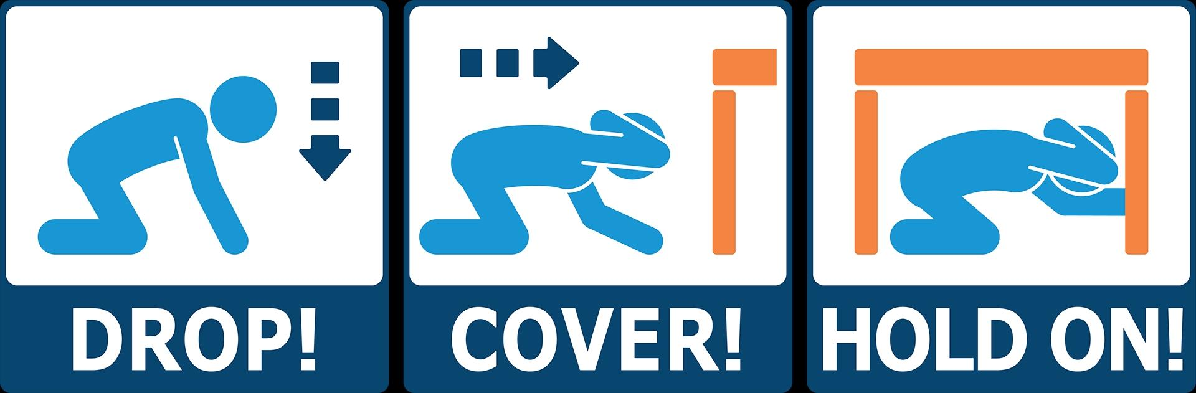
Identify Drop, Cover, Hold On spots in each room if an earthquake were to strike. This is the protective action you should take during an earthquake:
Your earthquake safe spots at home or work can be under a sturdy table, desk, or other piece of furniture. If there is no sturdy furniture to get under, get low beside an interior wall away from windows, mirrors, glass, or hanging objects. Move only when the shaking has stopped.
Room | Safe Spot
AVOID doorways, elevators, windows, or anything that can fall. Most injuries during earthquakes are due to falling while trying to move, or from falling objects themselves.
If outdoors, move to a clear area away from buildings, streetlights, utility wires, and trees. In a vehicle, pull over to a clear location, stop, and stay inside the vehicle with your seatbelt on until the shaking stops.

📅 13. Annual Preparedness Review
Preparedness isn’t something you do once and forget—it’s a routine. Emergencies can happen at any time, and keeping your plan and supplies up to date ensures your household is always ready. Every year, take time to:
- Update this Household Preparedness Plan
  - Review household members, contact numbers, medications, evacuation routes, and emergency contacts.
- Log into Teton_WY Alerts (Everbridge)
  - Visit https://tcincident.org and verify or update your contact information and address to receive accurate emergency alerts.
- Check your 2 Weeks Ready Kit
  - Inspect food and water supplies for expiration. Replace used or expired items. Test flashlights, radios, and other gear—swap out batteries if needed.
- Test smoke and carbon monoxide detectors
  - Change batteries and verify alarms are working at every level of your home.
- Check your NOAA Weather Radio
  - Confirm it powers on, receives broadcasts, and replace batteries proactively.
- Participate in The Great Wyoming Shake Out, the world’s largest earthquake drill on the third Thursday of October each year to practice your earthquake safety skills.
🗓️ Tip: Schedule this review on a recurring date that’s easy to remember—like the first day of spring, during National Preparedness Month (September), or when daylight saving time changes.

