C | JHFEMS Primary Zone | 01 | 22FIRE1 | WyoLink - JH Fire TG 1
C | JHFEMS Primary Zone | 02 | 22FIRE2 | WyoLink - JH Fire TG 2
C | JHFEMS Primary Zone | 03 | 22FIRE3 | WyoLink - JH Fire TG 3
C | JHFEMS Primary Zone | 04 | FireTac3 | JHFEMS Tactical 3
C | JHFEMS Primary Zone | 05 | FireTac4 | JHFEMS Tactical 4
C | JHFEMS Primary Zone | 06 | SJH er | SJH EMS/ER (Patient Reports)
C | JHFEMS Primary Zone | 07 | VMed28 | Regional Medical Interop and WY Air to Ground
C | JHFEMS Primary Zone | 08 | 22SAR1 | WyoLink - TC SAR TG 1
C | JHFEMS Primary Zone | 09 | 22LAW1 | WyoLink - TC Law TG 1
C | JHFEMS Primary Zone | 10 | 22CAT1 | WyoLink - Teton County Area TG 1
C | JHFEMS Primary Zone | 11 | Jac ARFF | JH Airport Rescue Firefighter Repeater
C | JHFEMS Primary Zone | 12 | GTP Sig Prim | GTNP Signal Mtn Primary Repeater
C | JHFEMS Primary Zone | 13 | BTF Rend | BTNF Rendezvous Repeater
C | JHFEMS Primary Zone | 14 | Enet SK | ENET Snow King Repeater
C | JHFEMS Primary Zone | 15 | Enet RR | ENET Rosies Ridge Repeater
C | JHFEMS Primary Zone | 16 | Enet PW | ENET Pow Wow Repeater
D | TC SAR Primary Zone | 01 | 22SAR1 | WyoLink - TC SAR TG 1
D | TC SAR Primary Zone | 02 | 22SAR2 | WyoLink - TC SAR TG 2
D | TC SAR Primary Zone | 03 | 22FIRE1 | WyoLink - JH Fire TG 1 - Dispatch
D | TC SAR Primary Zone | 04 | 22CAT1 | WyoLink - Teton County Area TG 1
D | TC SAR Primary Zone | 05 | 22CAT2 | WyoLink - Teton County Area TG 2
D | TC SAR Primary Zone | 06 | SAR Tac | TC SAR Tactical
D | TC SAR Primary Zone | 07 | Garn Rpt | Garn (Relay Ridge) Repeater
D | TC SAR Primary Zone | 08 | VMed28 | Regional Medical Interop and WY Air to Ground
D | TC SAR Primary Zone | 09 | VTac14 | VHF Tac14 & Nat’l SAR Command
D | TC SAR Primary Zone | 10 | GTP SAR Tac | GTNP Backcountry Ranger Rescue Tactical
D | TC SAR Primary Zone | 11 | NASAR | National SAR (also JHMR crossband?)
D | TC SAR Primary Zone | 12 | BTF Rend | BTNF Rendezvous Repeater
D | TC SAR Primary Zone | 13 | GTP Sig Prim | GTNP Signal Mtn Primary Repeater
D | TC SAR Primary Zone | 14 | Enet PW | ENET Pow Wow Repeater
D | TC SAR Primary Zone | 15 | Enet RR | ENET Rosies Ridge Repeater
D | TC SAR Primary Zone | 16 | SAR Rpt | TC SAR Rendezvous Repeater
E | Teton Interoperability Zone | 01 | 22LAW1 | WyoLink - TC Law TG 1
E | Teton Interoperability Zone | 02 | 22FIRE1 | WyoLink - JH Fire TG 1 - Dispatch
E | Teton Interoperability Zone | 03 | 22CAT1 | WyoLink - Teton County Area TG 1
E | Teton Interoperability Zone | 04 | 22CAT2 | WyoLink - Teton County Area TG 2
E | Teton Interoperability Zone | 05 | Enet SK | ENET Snow King Repeater
E | Teton Interoperability Zone | 06 | Enet RR | ENET Rosies Ridge Repeater
E | Teton Interoperability Zone | 07 | Enet PW | ENET Pow Wow Repeater
E | Teton Interoperability Zone | 08 | VTac12 | VHF Tac12 On Scene Tactical
E | Teton Interoperability Zone | 09 | VTac14 | VHF Tac14 & Nat’l SAR Tactical
E | Teton Interoperability Zone | 10 | SAR Rpt | TC SAR Rendezvous Repeater
E | Teton Interoperability Zone | 11 | GTP SAR Tac | GTNP Backcountry Ranger Rescue Tacticaltical
E | Teton Interoperability Zone | 12 | Mut Aid Dir | Mutual Aid (WHP) Direct
E | Teton Interoperability Zone | 13 | Jac ARFF | JH Airport Rescue Firefighter Repeater
E | Teton Interoperability Zone | 14 | BTF Rend | BTNF Rendezvous Repeater
E | Teton Interoperability Zone | 15 | GTP Sig Prim | GTNP Signal Mtn Primary Repeater
E | Teton Interoperability Zone | 16 | VMed28 | Regional Medical Interop and WY Air to Ground
N | Teton Wildland IA Zone | 01 | Enet SK | ENET Snow King Repeater
N | Teton Wildland IA Zone | 02 | Enet RR | ENET Rosies Ridge Repeater
N | Teton Wildland IA Zone | 03 | Enet PW | ENET Pow Wow Repeater
N | Teton Wildland IA Zone | 04 | BTF Rend | BTNF Rendezvous Repeater
N | Teton Wildland IA Zone | 05 | BTF Lava | BTNF Lava Repeater (Togwotee)
N | Teton Wildland IA Zone | 06 | BTF Rams | BTNF Ramshorn Repeater (Granite Creek)
N | Teton Wildland IA Zone | 07 | GTP Sig Prim | GTNP Signal Mtn Primary Repeater
N | Teton Wildland IA Zone | 08 | BTF Tac1 | BTNF Reg 4 Fire Tactical 1
N | Teton Wildland IA Zone | 09 | BTF Tac2 | BTNF Reg 4 Fire Tactical 2
N | Teton Wildland IA Zone | 10 | FireTac3 | JHFEMS Tactical 3
N | Teton Wildland IA Zone | 11 | FireTac4 | JHFEMS Tactical 4
N | Teton Wildland IA Zone | 12 | JHF Rpt | JHFEMS Apres Vous Repeater
N | Teton Wildland IA Zone | 13 | VFire21 | Regional fire interop, licensed to WY Fire Marshal, FERN
N | Teton Wildland IA Zone | 14 | FS Ag10 | Air to Ground assigned to B-T
N | Teton Wildland IA Zone | 15 | FS Ag19 | Air to Ground assigned to B-T
N | Teton Wildland IA Zone | 16 | Air Guard | National Fed FM Air Guard
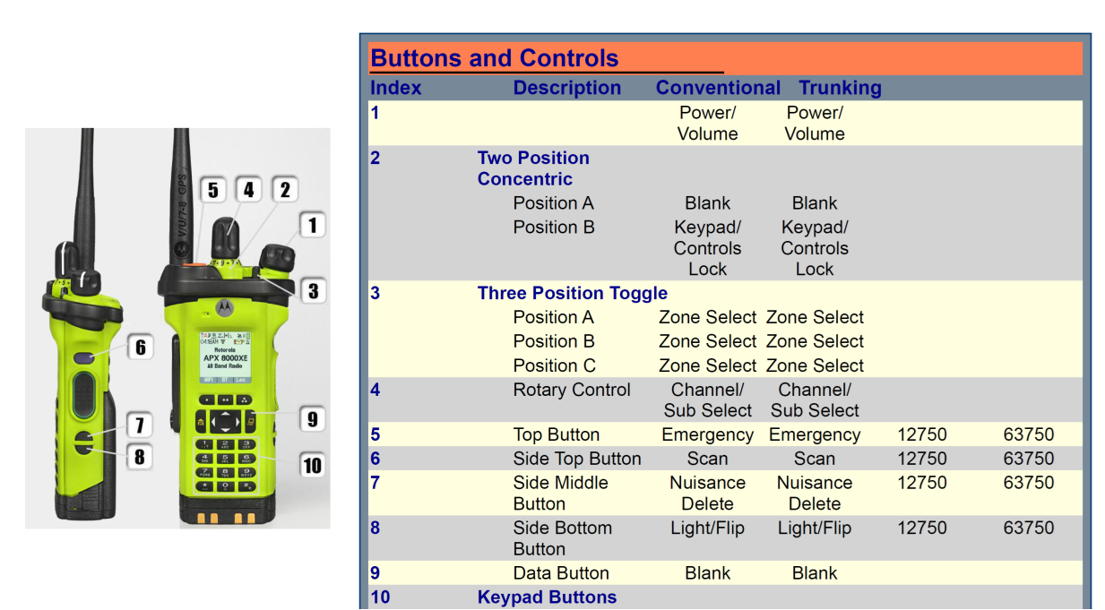
Blank RSSI – Signal Strength
Updated March 2025

