Emergency Response Plan [TEMPLATE]

[REPLACE IMAGE BELOW WITH EVENT/ORGANIZATION LOGO]


Organization Name: [ORGANIZATION NAME]
Event Name: [EVENT NAME]
Date Developed and Adopted: [DATE ADOPTED]
Date Reviewed and Updated: [DATE REVISED]
[Template Version 1.1; 06-05-2025]

Contents
How to Use This Template [DELETE THIS SECTION WHEN DONE] 2
Promulgation 3
Record of Changes 3
Event Description 4
[EVENT NAME] Planning Team 5
Event Crisis Team 6
Organization for Day(s) of the Event 7
Hazard Analysis 8
General Emergency Response Procedures 10
Hazard Specific Mitigations and Responses 12
Hazard Specific Response Sheets 13
Communications 14
Event Cancellation 15
Event Schedule 16
Event Map 17
Event Emergency Response Plan Exercises 18
Recommended Training 19
Helpful Apps 20

How to Use This Template [DELETE THIS SECTION WHEN DONE]
This template was designed by Teton County WY Emergency Management (em@tetoncountywy.gov) to assist special event organizers in Teton County and the Town of Jackson with emergency response planning for their events. Although emergency services may respond to an incident at special events, the safety of attendees and staff is ultimately the responsibility of the event organizer. The event staff and attendees will truly be the initial response to any emergency at the event before emergency services are called upon. This template is not a requirement for any special event permit in the Town of Jackson nor Teton County but is simply a tool for event organizers. This template is not all-inclusive and using this template does not release event organizers from their responsibility for the safety of event attendees and staff. Event organizers will need to use their own discretion based on the type of event they are hosting as to how they will use this template. This template is provided as a tool for special event organizers, and Teton County offers no guarantees nor accepts any liability for use of this template.
Before jumping into the template, event organizers will need to have a plan to develop the plan. The general process is:
- Identify core planning team (some of these may be the same person)
  - Event Organizer
    - Person submitting the event application to the Town/County
  - Event Emergency Response Plan (ERP) planner
    - Person facilitating the development of this plan
  - Event Emergency Coordinator
    - Expected to be on site during the entirety of the event
    - Would be the person in-charge during an emergency at the event
    - Would be the primary event liaison to emergency services
  - Key stakeholders
- Conduct risk assessment with core planning team
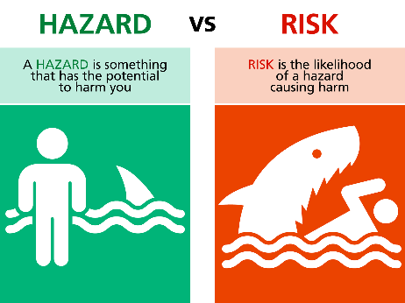
  - Hazard vs. Risk
  - Identify hazards of concern in regard to the event
    - Natural Hazards – Natural event such as a severe weather, pandemic, or earthquake.
    - Technological Hazards – Hazards resulting from the failure of a human-made system, such as a dam failure, hazardous materials spill, foodborne illness, or communications outage due to a failed switch.
    - Adversarial Hazards – Hazards resulting from willful actions by humans to cause harm to people, animals, property, and/or the environment, such as active shooter, bomb threats, cyber-attack, or vehicle ramming attacks.
  - Rank hazards based on risk to the event
    - (Probability + Scope + Impact + Warning Time + Duration)/5 = Risk Rating
    - The top 5 hazards can form the basis of the Emergency Response Plan focus
- Begin gathering information to include in this template.
  - Items in brackets and highlighted yellow [LIKE THIS] are intended to be replaced with detailed text from the planner. Feel free to add or remove any parts of this template in any way.

Promulgation
The [EVENT NAME] Emergency Response Plan was developed by [ORGANIZATION NAME] to help provide for the safety and well-being of [EVENT NAME] attendees, bystanders, and staff taking place on [EVENT DATES]. This plan has been reviewed by [ORGANIZATION NAME] for completeness and has been shared and reviewed with all appropriate event staff and stakeholders.

______________________________________ _______________________________
[ORGANIZATION LEADER NAME] Date
[ORGANIZATION LEADER TITLE]

Record of Changes
If this plan is to be used again for this event in future years, record any updates and changes made.
Date of Change | Description | Made By

Event Description
Event Name: | [NAME OF EVENT]
Event Date(s): | [DATES AND TIMES OF EVENT]
Event Location: | [EVENT LOCATION]
Event Description: | [NARRATIVE DESCRIPTION OF EVENT]
Recurring Event: | [INDICATE IF THIS IS A RECURRING EVENT, IF SO, HOW MANY YEARS?]
Sponsoring Organization: | [SPONSORING ORGANIZATION NAME]
Event Organizer: | [EVENT ORGANIZER NAME, CELL NUMBER, AND EMAIL]
Event Emergency Coordinator: | [EVENT EMERGENCY COORDINATOR NAME, CELL NUMBER, AND EMAIL]
Event Security: | [EVENT SECURITY COMPANY NAME AND SUPERVISOR NAME AND CONTACT INFO; IF NO EVENT SECURITY, LIST N/A]
Event Command Post Location: | [CENTRAL LOCATION WHERE KEY EVENT STAFF WILL BE DURING THE EVENT]
Event Briefing Meeting: | [TIME/DATE/LOCATION OF ANY REGULARLY SCHEDULED EVENT STAFF BRIEFING MEETINGS]
Event First Aid/Medical: | [EVENT CONTRACTED FIRST AID TENT OR MEDICAL AID PROVIDER COMPANY NAME AND SUPERVISOR NAME AND CONTACT INFO; IF NO CONTRACTED MEDICAL SERVICES, LIST N/A]
Expected # of Attendees: | [# OF ATTENDEES EXPECTED]
# of Event Staff: | [# OF EVENT STAFF]
Anticipated Issues: | [ANY ISSUES ANTICIPATED AT THE EVENT SUCH AS PROTESTORS, CROWD CONTROL, TRAFFIC ISSUES, ETC.]

[EVENT NAME] Planning Team
[THE SAME PERSON MAY FILL MULTIPLE ROLES – CONSOLIDATE AS NEEDED]
Role | Name | Email | Cell
[SPONSOR ORGANIZATION] Leader
[EVENT NAME] Organizer
[EVENT NAME] Emergency Response Planner
[EVENT NAME] Emergency Coordinator
[STAKEHOLDER 1]
[STAKEHOLDER 2]
[STAKEHOLDER 3]
[STAKEHOLDER 4]
[STAKEHOLDER 5]

Planning Schedule
[DEPENDING ON THE COMPLEXITY OF YOUR EVENT, IT MAY REQUIRE SEVERAL PLANNING MEETINGS. DOCUMENT THE EVENT PLANNING MEETING SCHEDULE BELOW THEN DELETE THIS.]
Date | Time | Location | Topic | Attendees

Event Crisis Team
Should an incident occur at the special event, the Event Crisis Team will be convened to determine to what extent this Emergency Response Plan (ERP) should be activated, or if the event itself should be cancelled. If an incident arises that is not addressed by this plan, the Event Crisis Team should be convened by the Event Organizer or Event Emergency Coordinator. [TIP: KEEP THIS TEAM SMALL, AS THE BIGGER IT IS, THE HARDER IT WILL BE TO CONVENE IN AN EMERGENCY]
Name | Title | Email | Cell Phone | Other (radio, etc.)

Event Crisis Team Responsibilities
- Ensure accountability and safety of all event staff, participants, and bystanders.
- Ensure entire Event Crisis Team is signed up for local emergency alerts through Teton_WY Alerts powered by Everbridge to maintain awareness of other emergencies near the event
  - Visit www.tcincident.org and click Sign Up to register. Use the same link and click Update to update or delete your account.
- Activate this Emergency Response Plan based on applicable warnings received on developing emergencies.
- Determine if an emergency incident justifies cancelling the event.
- Put event cancellation procedures into motion when warranted.
- Work with arriving emergency services to coordinate emergency response.
- Following an emergency, contact event insurance provider and legal counsel as necessary.

Event Crisis Team Notifications
There are several ways the Event Crisis Team can be notified and convened:
- The Event Organizer or Event Emergency Coordinator will create an SMS text message group with the Event Crisis Team and test it prior to the event. This text group will be used by the Event Crisis Team to quickly communicate during the event.
- The Event Organizer or Event Emergency Coordinator will create an email distribution list with the Event Crisis Team and test it prior to the event. This email distribution list can be used if text messaging fails during the event.
- [DELETE IF RADIOS ARE NOT USED] The Event Crisis Team will all scan radio channel [CHANNEL #] and use it to quickly communicate about developing incidents or convene to make decisions.
- [INSERT ANY OTHER COMMUNCATION METHODS THE EVENT CRISIS TEAM MAY HAVE]
- If communications between the Event Crisis Team cannot be established, all Event Crisis Team members will meet at [INSERT RALLY POINT AT EVENT] and convene.

Organization for Day(s) of the Event
[INSERT AN ORGANIZATIONAL CHART OR DESCRIPTION OF EVENT DAY STAFF AND REPORTING STRUCTURE. EXAMPLE BELOW, ADJUST AS NEEDED]

Hazard Analysis
Hazard | Probability | Scope | Impact | Warning Time | Duration | Risk Score
[HAZARD 1] | [USE TABLES BELOW FOR VALUES] | [USE TABLES BELOW FOR VALUES] | [USE TABLES BELOW FOR VALUES] | [USE TABLES BELOW FOR VALUES] | [USE TABLES BELOW FOR VALUES] | [USE FORMULA BELOW, SORT FROM HIGHEST TO LOWEST]
[HAZARD 2]
[HAZARD 3]
[ADD OR DELETE HAZARDS AS APPROPRIATE]
Risk Score = (Probability + Scope + Impact + Warning Time + Duration) / 5

Probability
What is the likelihood of the hazard occurring during the event?
Probability | Criteria | Value
Unlikely | Less than 1% | 1
Occasional | Between 1% and 10 % | 2
Likely | Between 10% and 90% | 3
Highly Likely | Greater than 90% | 4

Scope
How widespread is the impact?
Scope | Criteria | Value
Negligible | No people or a few properties if any | 1
Small | 1 -2 people or several properties | 2
Moderate | 3 – 5 people or most properties | 3
Significant | 5 + people impacted | 4

Impact
What are the hazard’s impacts to life and property?
Impact | Criteria | Value
Minor | No injury or light property damage if any | 1
Limited | Minor injury or moderate property damage | 2
Critical | Significant injury or major property damage. | 3
Catastrophic | Death or destroyed property | 4

Warning Time
Does the hazard have any warning before it strikes?
Warning | Value
More than 24 hours | 1
12-24 hours | 2
6-12 hours | 3
Less than 6 hours | 4

Duration
How long does the hazard last?
Duration | Value
Less than 30 minutes | 1
30 minutes to 60 minutes | 2
60 minutes to 120 minutes | 3
120 minutes or longer | 4

General Emergency Response Procedures
These procedures are common to all incident responses at the [EVENT NAME] and should be followed by all event staff. All event staff are expected to remain vigilant for safety issues, remedy them if it is safe to do so, and notify their supervisor of any emergency incidents. Frequent and open communication is key to a safe event for attendees and staff.
These procedures follow FEMA’s “You Are The Help Until Help Arrives” material. It is highly recommended that all event staff take the independent study training for this program listed in the Training section of this plan.
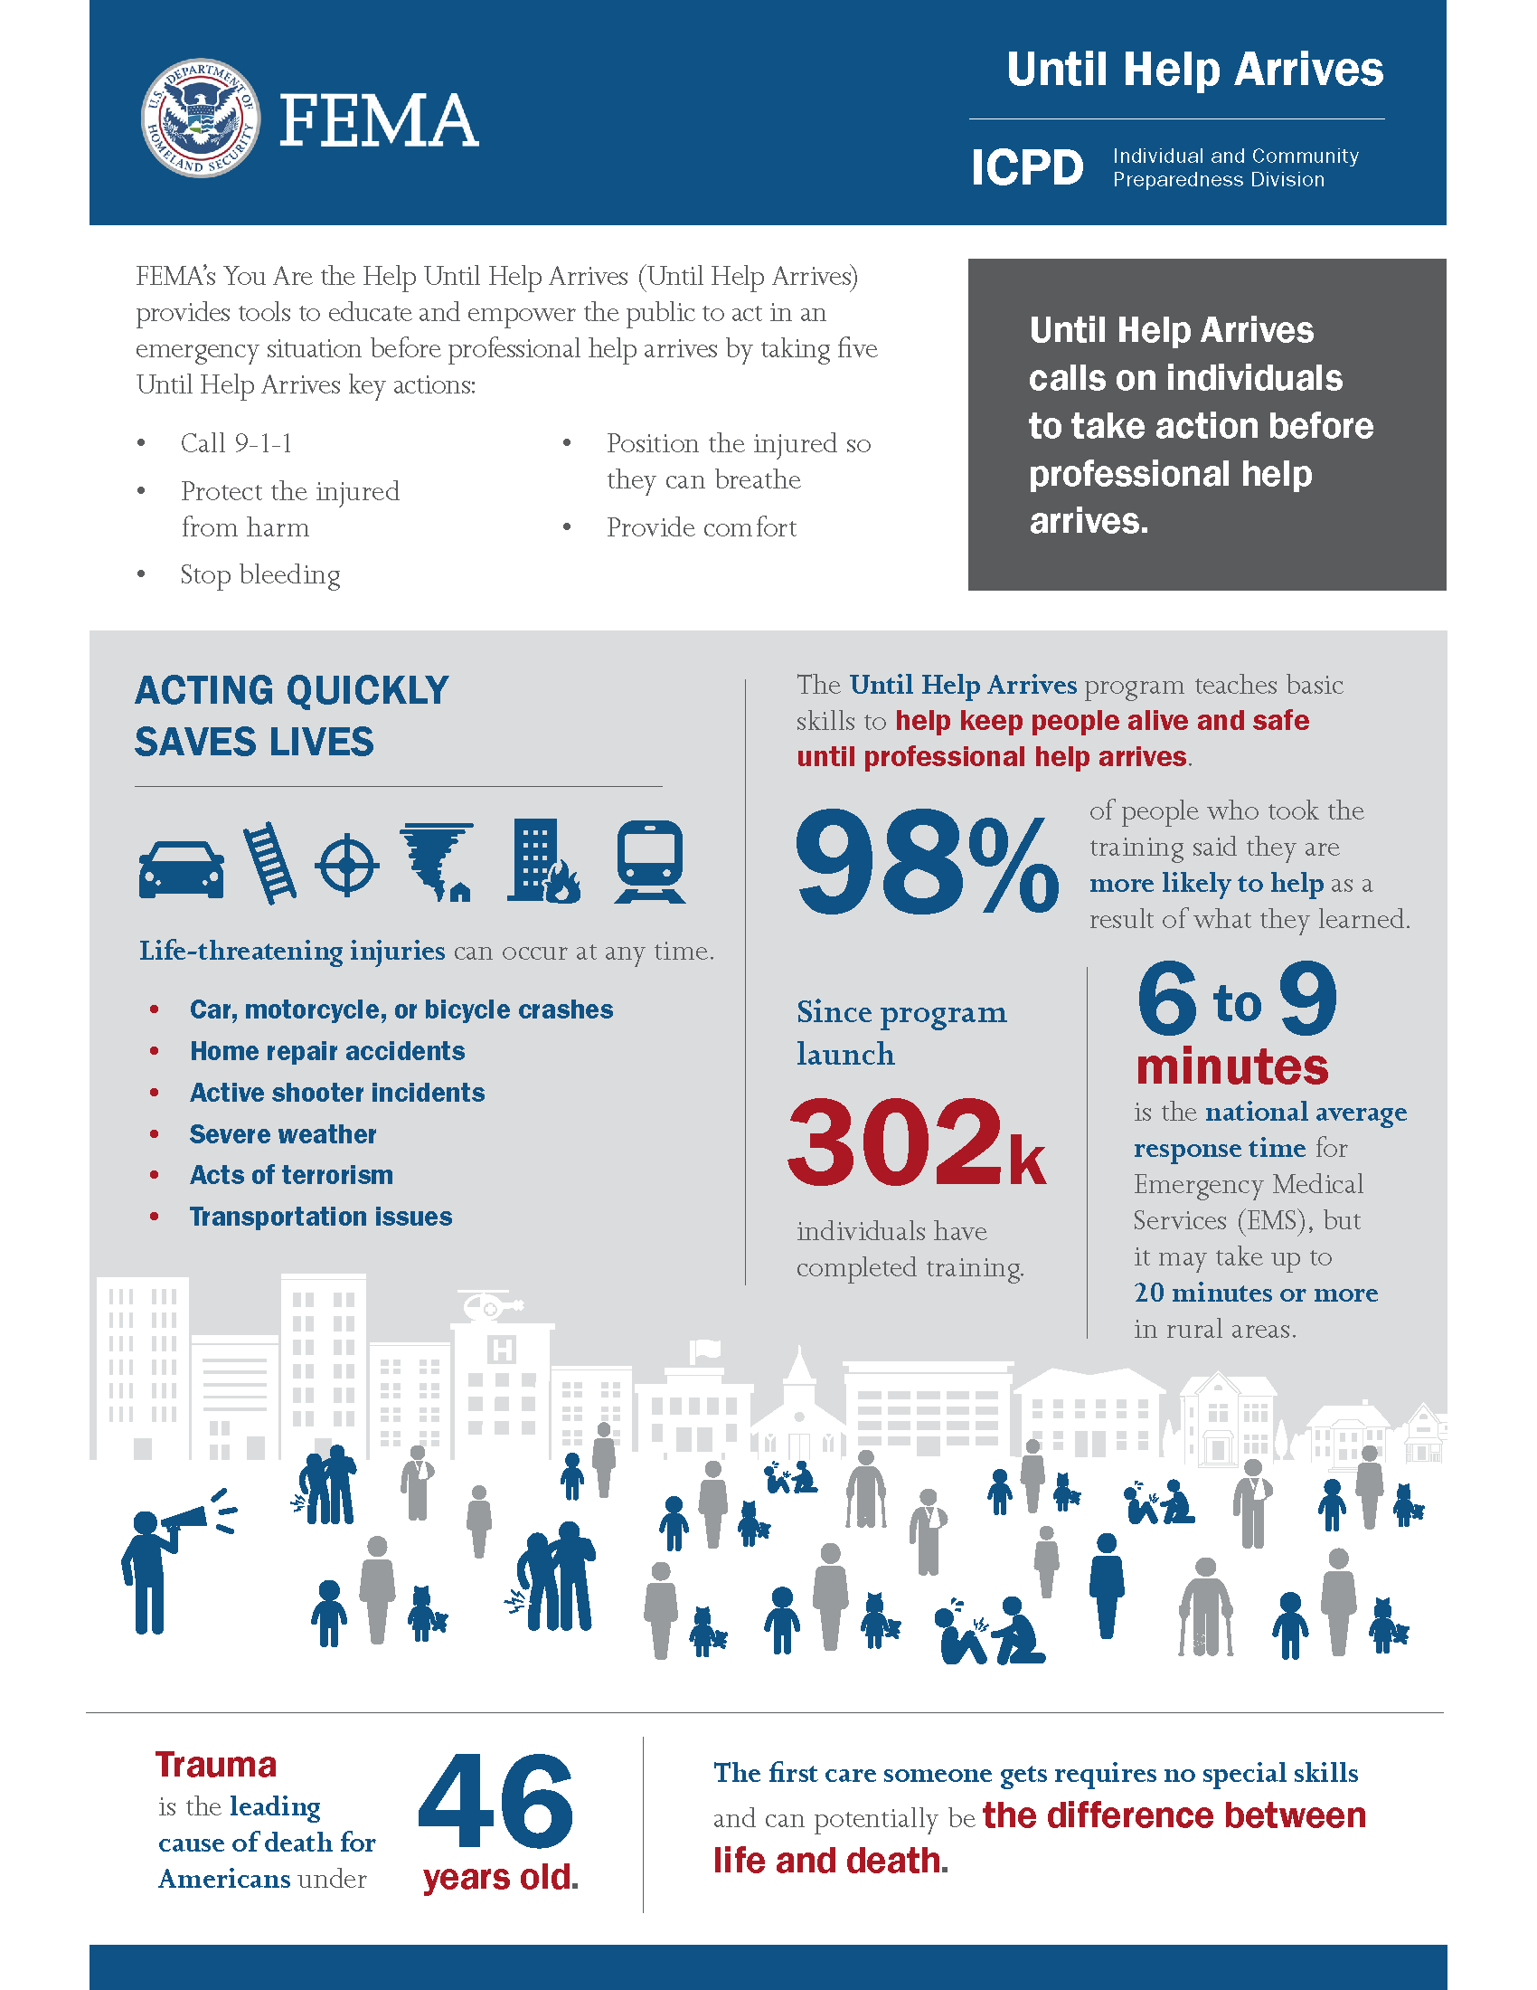

GENERAL EMERGENCY RESPONSE PROCEDURES
- Stop, take a deep breath, assess the situation.
- CALL 9-1-1 yourself or tell someone to if additional help is needed and provide:
  - Your exact location
  - The nature of the emergency including types of injuries, number of injured, property damage, and any ongoing hazards
  - Your callback phone number
  - Stay on the line and follow instructions given by 9-1-1 dispatcher
- STAY SAFE. Assess the situation and decide to stay and help, grab the injured and get to safety, or get yourself to safety. Alert others of the danger to keep them safe.
- STOP THE BLEEDING if there is any. Apply steady, firm pressure on the source of bleeding until emergency responders arrive. If you can’t control the bleeding with manual pressure, consider a tourniquet.
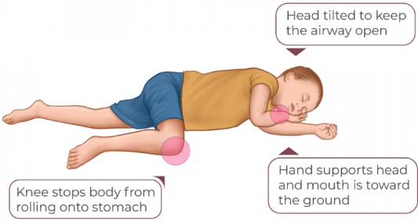
- POSITION THE INJURED. If conscious, allow them to position themselves. If unconscious, lay the injured on their side, legs slightly bent, with bottom hand reached outward and head resting near hand. Raise the chin forward with mouth pointed downward.
- PROVIDE COMFORT. Share names and ask basic questions. Tell them what you know happened, but don’t speculate. Keep them warm and offer a hand to hold.
- Notify the Event Organizer or Event Emergency Coordinator via [INSERT COMMUNICATION METHOD HERE].
Upon notification, the Event Organizer or Event Emergency Coordinator will convene the Event Crisis Team to assess the situation and make other determinations regarding the event.
Reference - FEMA’s “You Are The Help Until Help Arrives” program

Hazard Specific Mitigations and Responses
[USE THE TOP 5 (OR MORE) HAZARDS FROM YOUR RISK ANALYSIS AND PUT THEM INTO THE TABLE BELOW THEN DELETE THIS]
Hazard | Mitigations | Special Response Procedures
[EXAMPLE – THUNDERSTORMS] | - Event Emergency Coordinator will monitor NOAA Weather Radio  - Lighting alert app set for 10-mile radius of event  - Bookmarked National Weather Service website for up-to-date weather info  - Event Emergency Coordinator will distribute weather forecast to event staff during day of event | - If lightning detected within 10 miles, Event Crisis Team will convene to determine if event should be paused  - If lightning detected within 1 mile, announcement will be made on public address system advising everyone to head to their vehicles or events center.
[EXAMPLE – FOODBORNE ILLNESS] | - Hand washing stations for both food handlers and attendees  - Event Emergency Coordinator will walk through food preparation area hourly to ensure cleanliness and handwashing | - If foodborne illness is reported to staff, Teton County Environmental Health will be immediately notified by the Event Organizer and all food serving will be suspended.
[EXAMPLE – ACTIVE ASSAILANT] | - All security personnel will take FEMA’s Active Shooter Prevention course.  - All event staff will take FEMA’s Active Shooter: What You Can Do course.  - Event Emergency Coordinator will brief all event staff on “See Something, Say Something” to encourage suspicious item or activity reporting to event security.  - Security will check all bags upon entry to venue for prohibited weapons | - Upon notice of an active assailant, announcement will be made on public address advising public that an active assailant is at the venue and everyone should immediately run to a safe location, hide if they cannot run, and fight the assailant if they cannot hide.  - Security personnel will open all restricted entrances to allow for quick egress.
[HAZARD #4]
[HAZARD #5]

Hazard Specific Response Sheets
[FOR SPECIFIC HAZARDS LISTED IN HAZARD MITIGATIONS AND RESPONSES TABLE. IF FULL “TEAR AWAY” SHEETS ARE NEEDED FOR STANDARD OPERATING PROCEDURE PURPOSES FOR EVENT STAFF. TAKE INFO FROM “SPECIAL RESPONSE PROCEDURES” COLUMN AND EXPAND ON THEM. DELETE THIS SECTION IF YOU DON’T NEED SOP TEAR AWAY SHEETS.]

[HAZARD NAME]
[DETAILS]

[HAZARD NAME]
[DETAILS]

[HAZARD NAME]
[DETAILS]

Communications
Communication between event staff and with event attendees is critical during an emergency.

Internal Communications to Event Staff
Communication Method | Audience
[EXAMPLE Handheld radios] | Event security
[EXAMPLE Event Crisis Team group text] | Event Crisis Team
[EXMPLE Event group text] | All event staff

External Communications to Event Attendees
Communication Method | Authority to Activate | Ability to Activate
[EXAMPLE Public address system] | Event Organizer | Sound booth technician
[EXAMPLE Eventbrite email list] | Event Organizer | Event promoter
[EXAMPLE Signs at venue entrance] | Event Emergency Coordinator | Security staff

Scripted Messages
[INSERT PRE-SCRIPTED MESSAGES THAT CAN BE READ OVER PUBLIC ADDRESS OR COPIED INTO EMAIL/TEXT MESSAGES TO EVENT ATTENDEES. USE TOP RANKED HAZARDS AS MESSAGE SUBJECTS AS APPROPRIATE]

[EXAMPLE Severe Thunderstorm Message]
Your attention please. A severe thunderstorm with dangerous lightning is approaching the area. Please proceed to the nearest exit and take shelter in your vehicle or the event center lobby until all clear message is given.

[EXAMPLE Active Assailant Message]
Your attention please. An active assailant has been seen in the venue. Take cover immediately and leave the area if safe. If you are unable to leave, hide from the assailant. If you are unable to hide and are confronted by the assailant, fight the assailant. Emergency responders have been notified and are on their way.

[EXAMPLE Explosion]
Your attention please. There has been an explosion at the venue due to an unknown cause. If you are able, please proceed to the nearest exit. Those needing medical attention should report to the medical aid station.

[EXAMPLE Missing Child]
Your attention please. A 5-year-old male named Javier with brown hair and blue eyes wearing a blue ball cap, red t-shirt, and shorts is missing. He was last seen near the food court. If you have seen Javier, please contact the nearest security officer.

Event Cancellation

Event Cancellation Information
Event Cancellation Information
Who has the authority to cancel the event? | [GROUP OR PERSON WHO CAN CANCEL]
Under what conditions might the event be cancelled? | [LIST CONDITIONS]
How will the event organizer notify staff that the event is cancelled? | [LIST NOTIFICATION METHODS]
How will the event organizer notify attendees and the public that the event is cancelled? | [LIST NOTIFICATION METHODS]
What logistical issues will event cancellation cause? | [LIST LOGISTICAL ISSUES]
How can those logistical issues be mitigated? | [LIST LOGISTICAL ISSUE MITIGATIONS]

Event Cancellation Procedures
[LIST PROCEDURES TO CANCEL EVENT BOTH PRIOR TO EVENT START AND DURING EVENT. BELOW IS A FLOW CHART YOU CAN USE WITH EXAMPLES BUT SHOULD BE EDITED FOR YOUR SPECIFIC EVENT. FEEL FREE TO USE THE DIAGRAM OR INSERT YOUR OWN, THEN DELETE THIS.]

Event Schedule
[INSERT YOUR OWN EVENT SCHEDULE BELOW AND DELETE THE TABLE OR USE THE TABLE TO PROVIDE A DETAILED EVENT SCHEDULE. THIS CAN HELP EVENT STAFF TO STAY COORDINATED, BUT ALSO ASSIST EMERGENCY SERVICES IF THEY NEED TO RESPOND TO AN INCIDENT AT YOUR EVENT. DELETE THIS WHEN DONE.]
Date | Time | Activity | Location

Event Map
[INSERT EVENT MAP HERE THEN DELETE THIS AND THE ICON BELOW]


Event Emergency Response Plan Exercises
[SOME EVENTS MAY BE COMPLEX ENOUGH TO REQUIRE A DRY RUN OR EXERCISE OF THE EMERGENCY RESPONSE PLAN WITH STAFF. THIS CAN EITHER BE WRITTEN BEFORE THE EXERCISE, OR AFTER THE EXERCISE HAS TAKEN PLACE AND DOCUMENT WHAT WAS LEARNED FROM IT. IF THAT IS THE CASE, DOCUMENT IT HERE THEN DELETE THIS. OTHERWISE, DELETE THIS SECTION IF NO EXERCISES WILL TAKE PLACE.]

Exercise Details
Due to the size and complexity of this incident, event staff [WILL PARTICIPATE/HAVE PARTICIPATED] in a dry run exercise of this emergency response plan. This exercise [WILL TAKE OR HAS TAKEN] place on [INSERT DATE/TIME] at [LOCATION]. This [WILL BE/WAS] a [SEMINAR/TABLETOP EXERCISE/FUNCTIONAL EXERICSE/FULL-SCALE EXERCISE] that the following staff [ARE/WERE] required to attend:
- [LIST STAFF POSITIONS REQUIRED TO ATTEND]
[IF WRITTEN AFTER THE EXERCISE, USE THE TABLE BELOW TO RECORD RESULTS FROM EXERCISE. IF WRITTEN BEFORE EXERCISE, DELETE THIS AND TABLE BELOW]

Exercise Observed Strengths
The following table documents strengths observed during the exercise:
Strength Observed

Exercise Observed Areas for Improvement and Corrective Actions
The following table documents areas for improvement observed during the exercise with corrective actions:
Area for Improvement Observed | Corrective Action

Recommended Training
The following training is recommended for special event staff to help them better mitigate emergencies, integrate with emergency services, and respond to emergencies at their events.

Free Online Independent Study Courses
- FEMA’s “You Are the Help Until Help Arrives” program and training
- Stop the Bleed interactive course
- Jackson Hole Fire/EMS Hands-Only CPR Video (54 seconds)
- FEMA’s “Active Shooter: What You Can Do”
- FEMA’s “Active Shooter Prevention: You Can Make A Difference”
- FEMA’s “Special Events Contingency Planning for Public Safety Agencies”
- FEMA’s “Intro to the Incident Command System”
- CISA’s “Check It! – Bag Check Video” (8 minutes, 35 seconds)
- CISA’s “Vehicle Ramming Attack Mitigation Video” (12 minutes, 39 seconds)
- CISA’s “Options for Consideration Active Shooter Preparedness Video” (7 minutes, 47 seconds)
- FEMA’s “Organizations Preparing for Emergency Needs (OPEN)” program and training

Paid Online Independent Study Courses
- Crowd Manager Training Program
- ServSafe food and alcohol safety courses
- American Red Cross First Aid/CPR/AED courses

In-Person Courses
- Teton County Sheriff’s Office Active Shooter Training – 307-733-4052
- Jackson Police Department Training for Intervention Procedures (TIPS) course – 307-733-1430
- Jackson Police Department Shoplifting Prevention Training – 307-733-1430
- Teton County Health Department ServSafe Food Manager exam proctoring

Helpful Apps
These applications can be helpful when planning events or for event operations.
App | Description
511 Notify | WYDOT’s SMS text message service for state highway issues. Register for alerts for only the roads you are interested in. (FYI, most roads in the County are State highways).
Everbridge App | Get Teton_WY Alerts from Teton County Emergency Management as push notifications. Search for Teton_WY Alerts to subscribe to our messages.
FEMA App | Get real-time weather alerts for your area
GroupMe | Group text messaging app to help with communications among your event team
My Lightning Tracker (Android) (iOS) | Help track lightning in the area of your outdoor event
Teton WY Weather and Hazards Viewer | Map series created by Teton County Emergency Management that covers weather, traffic, power outages, and more to help with your event situational awareness.
Watch Duty | Mobile app and web application for real-time wildfire situational awareness.
Weather.gov/riw | National Weather Service – Riverton home page. National Weather Service office that covers Teton County, WY.
WhatsApp | Messaging application to help with communications among your event team
Wyoming 511 App | WYDOT’s mobile app with real time highway information, cameras, sensors, and more.

